Thesaurus

What is Thesaurus
# Source: AI Source: Provided by: [Data Path: Persons Table -> ID Column: 1, Name_En Column: Motasem Essam] -> From: [Chatgpt (GPT-4-turbo)] on [7/29/2025]
A Thesaurus is a reference tool that lists words grouped by similarity of meaning—that is, synonyms and sometimes antonyms. Unlike a traditional dictionary, which defines words, a thesaurus helps users find alternative words to enrich their writing or speech.

🔹 Key Features of a Thesaurus
# Source: AI Source: Provided by: [Data Path: Persons Table -> ID Column: 1, Name_En Column: Motasem Essam] -> From: [Chatgpt (GPT-4-turbo)] on [7/29/2025]
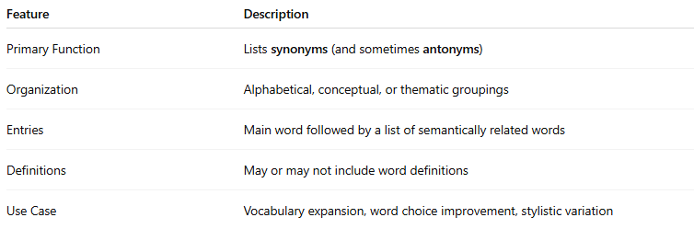
Feature | Description
Primary Function | Lists synonyms (and sometimes antonyms)
Organization | Alphabetical, conceptual, or thematic groupings
Entries | Main word followed by a list of semantically related words
Definitions | May or may not include word definitions
Use Case | Vocabulary expansion, word choice improvement, stylistic variation

🔹 Types of Thesauruses
# Source: AI Source: Provided by: [Data Path: Persons Table -> ID Column: 1, Name_En Column: Motasem Essam] -> From: [Chatgpt (GPT-4-turbo)] on [7/29/2025]
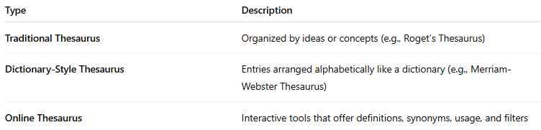
Type | Description
Traditional Thesaurus | Organized by ideas or concepts (e.g., Roget’s Thesaurus)
Dictionary-Style Thesaurus | Entries arranged alphabetically like a dictionary (e.g., Merriam-Webster Thesaurus)
Online Thesaurus | Interactive tools that offer definitions, synonyms, usage, and filters

🔹 Examples of Popular Thesauruses
# Source: AI Source: Provided by: [Data Path: Persons Table -> ID Column: 1, Name_En Column: Motasem Essam] -> From: [Chatgpt (GPT-4-turbo)] on [7/29/2025]
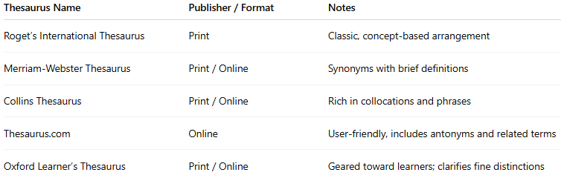
Thesaurus Name | Publisher / Format | Notes
Roget’s International Thesaurus | Print | Classic, concept-based arrangement
Merriam-Webster Thesaurus | Print / Online | Synonyms with brief definitions
Collins Thesaurus | Print / Online | Rich in collocations and phrases
Thesaurus.com | Online | User-friendly, includes antonyms and related terms
Oxford Learner’s Thesaurus | Print / Online | Geared toward learners; clarifies fine distinctions

🔹 Advantages
# Source: AI Source: Provided by: [Data Path: Persons Table -> ID Column: 1, Name_En Column: Motasem Essam] -> From: [Chatgpt (GPT-4-turbo)] on [7/29/2025]
- Improves vocabulary variety and nuance
- Helps avoid repetition in writing or speaking
- Encourages precise word choice
- Valuable for writers, students, editors, and translators

🔹 Use Cases
# Source: AI Source: Provided by: [Data Path: Persons Table -> ID Column: 1, Name_En Column: Motasem Essam] -> From: [Chatgpt (GPT-4-turbo)] on [7/29/2025]
- Creative writing and academic essays
- Editing and revising texts
- Language learning and vocabulary building
- Translation and localization work

